Negotiating What I Want ….

A “how to” focus resource
With Enabling Good Lives (EGL) and other new initiatives individuals and families have more flexibility to create the supports that they want. There is a real advantage in being able to effectively express what you want and how you want it so supports and services are able to fit in with your preferences. From time to time, there will also be the need for individuals and families to effectively present their point of view when there are differences of opinion. This resource is intended to assist developing negotiation skills.

Enabling Good Lives - The Principles
These concepts are the basis for all decisions and actions
Self-determination | - disabled people are in control of their lives
Beginning early | - invest early in families and whānau to support them to be ambitious for their disabled child  - to build community and natural supports  - to support disabled children to become independent.
Person-centred | - disabled people have supports that are custom-made to their individual needs and goals  - a whole life approach rather than being split across programmes.
Ordinary life outcomes | - disabled people are supported to live an everyday life in everyday places  - disabled people are regarded as citizens with opportunities for learning, employment, having a home and family, and social participation - like others at similar stages of life.
Mainstream first | - disabled people are supported to access mainstream services before specialist disability services.
Mana enhancing | - the abilities and contribution of disabled people and their families are recognised and respected.
Easy to use | - disabled people have supports that are simple to use and flexible
Relationship building | - supports build and strengthen relationships between disabled people, their whānau and community.

Building a Good Life
It is helpful to think about what a Good Life means before starting to express your preferences or negotiate. To plan early will also give clarity on possible contact with a service or support system the person might want assistance from. Negotiation can be improved when there are clear expectations on the outcome.

Communication Essentials - ESTABLISHING RAPPORT
Others
You
C
O
N
N
E
C
T
I
O
N

Establishing rapport is about making the person feel relaxed and free to talk, and comes from a combination of what you say, how you say it, and what you are doing when you say it.
You may need to:-
• Introduce yourself
• Say why you are there
• Explain why you wish to speak with / listen to this person
Be careful not to bias the discussion by indicating what you think is most important or what your opinions are. This may lead the person to form answers based on the signals you have unconsciously given off.
Questions: To ENCOURAGE a person to express their thoughts and feelings we ask:-
Open Questions
These are questions that cannot be answered with a yes or no, and do not 'lead' the person to answer. These questions may start with “how”, “what” or “why”, e.g “How can you assist me to achieve what I want?” Rather than “do you think you can assist?”
Closed Questions
These questions are used when you need to quickly receive information.
Closed questions are not ideal when you want a 'warm' and flowing dialogue, but when you want to know the facts. Closed questions are answered with yes or no.
Direct Questions
These are used to focus attention on a specific issue you want clarified. Direct questions are used if you have incomplete or distorted messages.
Sometimes you may need to briefly ask a closed or direct question in response to what a person is expressing - this then needs to be followed with another Open Question.

Perception Check
Perception checking is to clarify what has been said so you can:-
• Check your own understanding
• Show the other person that you are attempting to follow what they are expressing.
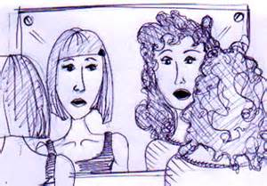
You can perception check by PARAPHRASING (saying the important things back to the person) what a person has expressed, so they can either:-
• Agree and go on with more detail, or
• Disagree, and restate what they are saying.
Perception checking is like being a mirror so you are then able to see whether you have understood or distorted a message. It is not used for interpreting, judging or analysing what has been expressed.
Summarizing
When we have been talking and listening for a while (perception checking to make sure we understand accurately) then we can pull out what we think the key themes are. These can be presented to the person and this allows them to:
• Clarify
• Go into more depth
Conflict and Negotiating
Conflict plays a regular and crucial role for change. Conflict can be the place where positions are clarified, perspectives are shared and new directions are established. Unfortunately, conflict an also be the place where unnecessary things occur, eg, people can feel victimised, allies can become enemies and precious resources can be eroded.
What we think (and feel) about conflict and the skills we have learned will be the most significant factor in determining whether conflict becomes a place of creativity, diversion or destruction.
Partnership and clarity both rely on occasional conflict occurring. Genuine partnerships need conflict so that the individual views remain distinct and perspectives are acknowledged.
Constructive conflict is when all of the perspectives are valued and a mutually beneficial resolution is sought.

Why does conflict happen?
Conflict occurs as a way for people to attempt to influence or achieve what they want.
This may be to improve a person’s understanding or to have things more the way they think they should be. The conflict only tends to become messy when there are other elements introduced to this, for example:
Fear | that a change will result in less than what people already have
Mistrust | things are not as they appear
Misunderstanding | different ideas about what was meant/intended
Control issues | one of the individuals/groups is attempting to control or dominate what is happening
Unwillingness | a person/party is closed to input from others or will not even consider altering their behaviour/practices
Habit | where an individual/group is so used to fighting for what they believe in that permanent conflict is created
Transference | one of the parties is shifting emotions and responses from one situation to another (without realising it).

Unnecessary conflict can appear inevitable in a process of change if there is a situation where there is:
• mixed expectation
• unclear communication
• stress
• a reactive culture present (in an individual or group).
When changes are happening, appropriate and necessary conflict is likely to occur when:
• clarification is required
• change or growth is happening
• people have different agendas and they are attempting to work together
• progress is reviewed and feedback given.

EGL is both about a whole new way of doing things (i.e. systems change) and about supports and services doing things in better ways (i.e. service transformation).
So, why might conflict exist as part of this change?
• People are increasing their Self-Determination
It is common for people to seek to define and refine who they are through conflict. As people gain more confidence and assertiveness, it is only natural that others are challenged. Rather than signalling “failure”, this type of conflict indicates success, ie, individuals have developed a voice and feel safe to express their opinion – even if it is different from expectations.
• Change
With the change process comes conflict, as there is a constant need for people to clarify what is happening and EGL involves considering doing things in different ways.
• Limited Resource
There is conscious (and covert) competition for attention, time, influence and resource. Even if all of the people involved are in complete agreement conflict is still likely to occur as people try to ensure their needs are met.

Conflict - A Catalyst for Positive Growth
Definition: Conflict is often about “struggle”, “collision” or “clashing”.
Conflict occurs when we have different views about the same situation. This comes from having differing values, experiences and expectations.
Knowing how to work constructively with conflict is one of the practical ways to bring life to concepts like “diversity” and “respect”.

Managing Conflict
Conflict can be healthy and powerful for learning and development.
Left unmanaged conflict can become confusing, messy and destructive. Managing conflict enables people to learn new skills in a safe and constructive environment and increases the chances that an acceptable, or helpful, resolution can be reached for all involved.
It is natural for people to see the world differently. Everybody carries their own perspective of a situation. People have differing skills to ensure that conflict is creative and constructive. Until a person has experienced effective conflict management they may not have been exposed to HOW to work creatively with conflict.
Some core principles of working in (and through) conflict to consider:
- Everyone is entitled to their perspective.
- Processes must create equity.
- Respect is an active (not passive) state.
- Responsibility for ensuring conflict is safe and constructive.
- Effective resolution is only possible when all parties have a willingness to clarify and resolve issues.
- There can be unity in diversity.
Approaches to managing conflict:
1. NEGOTIATION - acknowledge that there are differences and consciously work together to clarity perspectives, find places of understanding and agreement and ensure developing a way to work together that is mutually helpful.
2. FACILITATION - making it easier for people to describe what is going on for them and ways to find the next constructive step forward. This can involve an agreed framework that provides a “formula” for safety, direction and expression.
3. MEDIATION - bringing in a “third person” (often an external person with a high degree of ‘credibility’) to bring more structure to the discussion and process. Mediation does not involve the mediator making decisions about what an outcome should be.
4. ARBITRATION - involving a “third person” who can listen to all of the points of view then make a decision about the next steps.

Applying Negotiation Skills

Definition - Negotiation
“Confer with another view to compromise or agreement. To arrange or bring about a desired object.” Concise Oxford Dictionary, 1969
“Effective negotiation is unifying two peoples (groups) ideas.” Nancy Highshoe, 1997
“Successful negotiation is “following a few common sense rules to reduce conflict and turn it into co-operation and reach solutions that really work for all the participants.” The Negotiation Skills Company, 1994

Various Strategies in Conflict
Control trying to manage all possibilities to attempt to get what you want
Submit giving in or giving over to another person’s position
Compromise a process for settling for what appears to be fair and reasonable.
Negotiate | The process of clarifying expectations, aspirations and possible outcomes with the intention of all people potentially achieving what they want.

When is negotiation appropriate?
When you need to work something out with another person and there is the potential for conflict. It is sometimes wise to “negotiate” when making an approach in order to obtain something new or different.
Am I ready to negotiate?
Do I: know what I want?
know why I want it?
feel ok about working co-operatively?
think I am able to listen to the other point of view?
have some ideas / strategies?
have a back-up if the negotiation is unsuccessful?

Some Key Points
- Look for common ground. How can your needs and the needs of the other party can be met?
- Manage the process not the content, e.g, making sure everyone is heard, looking for what can be (not what isn’t!).
- Be flexible and creative – this may mean new options can be discovered.
- Remember that the objective of negotiation is to maintain, or improve, your relationship and reach a mutually acceptable outcome.
- Keep your integrity - be honest about thoughts, feelings and facts.

Components of Effective Negotiation
1. Find common ground.
- Build connection and trust.
- Establish a clear purpose for the discussion
2. State your interest.
- Why you want a certain thing or outcome.
- Prepare yourself to the point where you can state this in one or two sentences.
- At this point it is sometimes better not to state how you would like this achieved as you have not got all the information yet. Listen to the other person.
3. Listen carefully.
- Pay attention. Watch for non-verbal clues like body language.
- Silence is ok. It may be telling you the other person is willing to hear the other point of view. Silence can unsettle an aggressive response; giving them time to withdraw comments that were not helpful.
- Ask clarifying questions. Show that you are interested in their position and you want to understand it. This can be to your advantage if you want to propose something that meets their needs as well as yours.
- Reframe. Reframing means taking a statement and making it more positive. It is a deliberate strategy to encourage individuals to look more positively at a situation. It can be used as a mutual challenge. Here is an example, “I can’t see the point in coming to these meetings. There is a lot of talk but at the end of the day you will just do what you want to regardless of what I say. I think my time is wasted here”. Questions to ask yourself to help reframe might include What am I wanting?
How could this be achieved?
Identify the possible positive outcome if the change is made.
- Focus on what could be – not what isn’t.
4. Explore options.
- Separate the person from any apparent problem.
- List possibilities
- Ask the other person if they can see a way for you to achieve your aims.
- Volunteer how your ideas may meet the other person’s needs.
- Search for alternatives.
5. Summarise.
  - Ensure you are both on the same track.
  - Confirm any decisions made.
  - Check if there are any outstanding issues.
6. Develop a workable strategy / outcome that meet both parties’ needs.
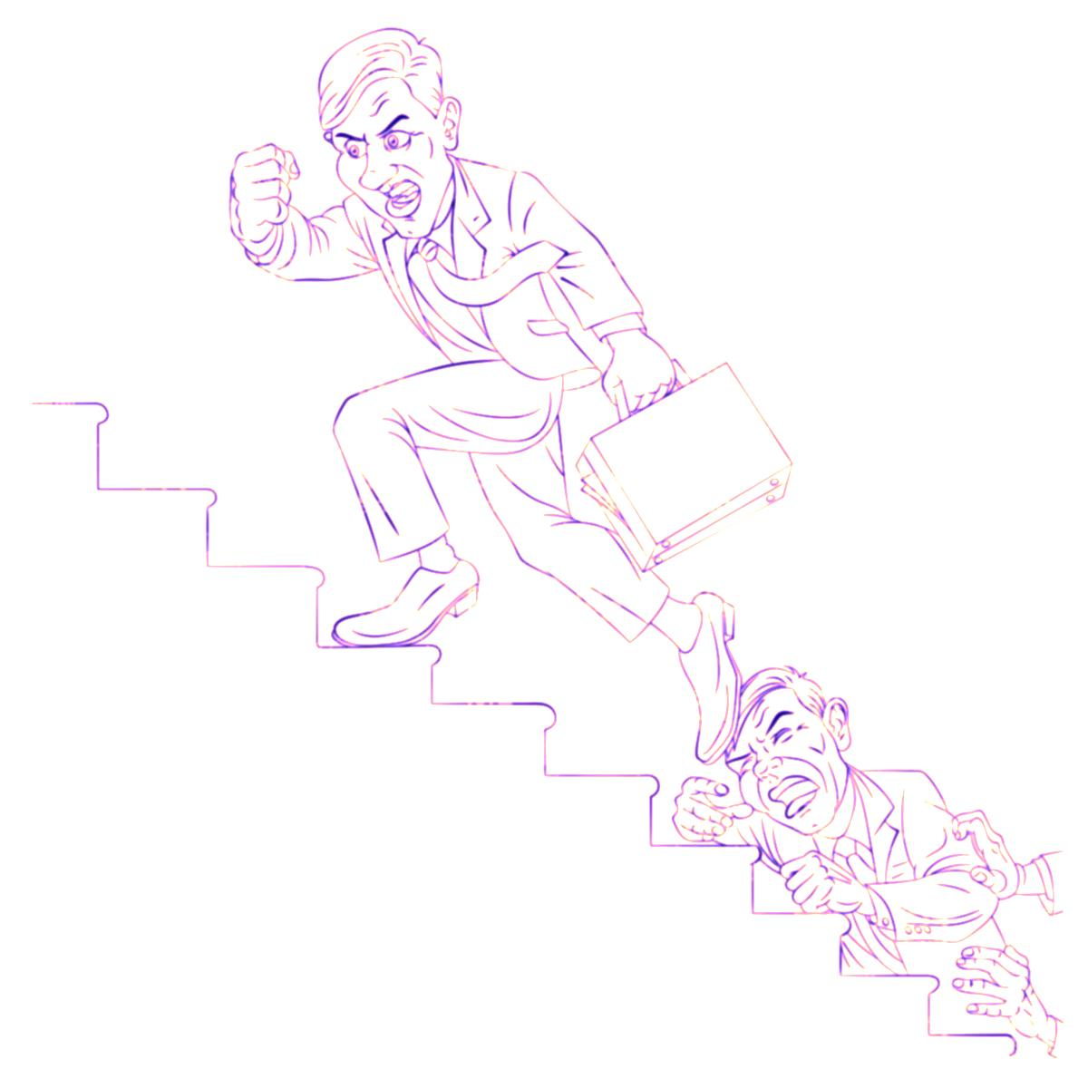
NINE STEPS TO MAKING CONFLICT MESSY….and ways to do it better!!

Messy Constructive Alternative
Take conflict personally;  whenever anyone has a different view take it as a personal attack. | See conflict as part of the clarification and growth process.  - Be clear about personal boundaries.  - Be open to the views of others – there is no need for everyone to see things the same way.
Attempt to change others | Take responsibility for “self”  - Demonstrate how you believe things can be.  - Suggest alternatives and describe the potential benefits they may have.
Reject the worth in a different view | Accept that people have different perspectives.
React to what we see as the “problem” | Discover what could work for the mutual advantage of everyone.
Assume it should be easy to sort something out | The time and energy invested in resolving conflict will probably save considerable resources in the medium and long term.  - Take the time to respond usefully.  - Invest focus and effort in identifying a positive outcome.
Feel superior in our “rightness” | - Be open to other ways of seeing and doing things.  - Be prepared to find better ways.
Pretend to be interested in resolution when really we are not willing to negotiate | Recognise that it is usually in everyone’s best interests to work co-operatively.
Blame others | Create and keep a productive environment.

The intent of the EGL approach is to make changes so disabled people and their families have control of their lives. This includes having the “say so” in how and why resources are used.
Adapted from Bower and Bower
DESC
Sometimes, when attempting to express our point of view, we can get caught up in being defensive or getting lost in what is not working for us. Below, is a simple framework to assist us to stay ‘neutral’ and present “what can be” (not what isn’t) in a way that increases the chance there is a positive result.
Packing Your Message and Increasing Your Chances!
This is a framework for
- combining your feelings about an experience,
- thoughts you have about how you would like it changed and
- the positive outcome when the change has been made.
In conflict situations you usually only have a couple of minutes to clearly state your perspective. This framework will assist you to do this in a constructive, and often successful, way.
Each step is one sentence only.
Describe the situation you wish to change.
Be as specific as possible using neutral language (leave out judgements, interpretations and generalisations), e.g. “Yesterday we were going to meet at 2.30pm and you did not arrive until 3.15pm.”
Express how you feel about the situation; try not to use lots of emotional words.
Briefly pause (take a breath) so the other party can understand and reflect on what you said, e.g. “I feel frustrated.” (pause)
Specify what you would like different.
Again, keep it descriptive and neutral. The other person knows what you are feeling so now is the time to give a clear suggestion for the circumstance to change, e.g. “When we make an arrangement I would like you to be on time or let me know you will be late.”
Consequences are the positive outcomes when the change has been made.
If possible, make the benefit mutual, e.g. “Then I will feel appreciated and we can continue to work together positively”.

