Enabling Good Lives Waikato

Evaluation

Part Three

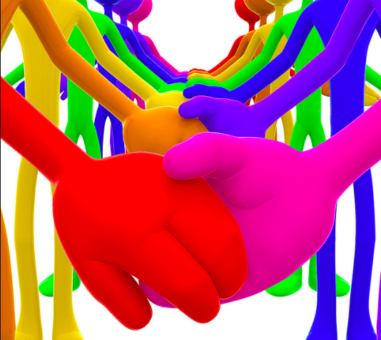

EasyRead Version by: Readable by Glen

Who is ‘The Demonstration’?

* 55 disabled people and their families

What is ‘The Demonstration’?

* It is done to look at how disabled people and their families achieve their goals.

The EGL Demonstration:

* This report explains what we learnt about the EGL Waikato Demonstration from the Phase Three evaluation.
* The evaluation looks at If people have been able to reach the goals they had when they started with EGL, and how much EGL helped with this.
* The phase 3 evaluation was done from April 2018 to November 2018. 55 disabled people, families and whānau talked about how they felt about their EGL journey.

What EGL do:

* Helped 91% of participants complete half or more of their goals.
* Offer Flexibility and Freedom
* Support people to look after their own money
* Help make personal budgets
* Build Tuhono/Connector Relationships
* Provide support.

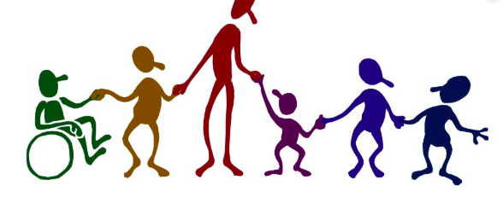

What the people of EGL have said:

|  |  |
| --- | --- |
| EGL has built their  confidence | They have made Friends |
| Are able to participate in more things | They have a sense of independence |
| They have more opportunities | Having a say in their support workers |

Enabling Good Lives:

* EGL is a group that forms partnerships between the disability sector
* The ‘disability sector’ is, disabled people, families, whanau and providers of disability support.

EGL Vision:

* In future disabled children, adults and their families will have more of a choice and control over their supports and lives.

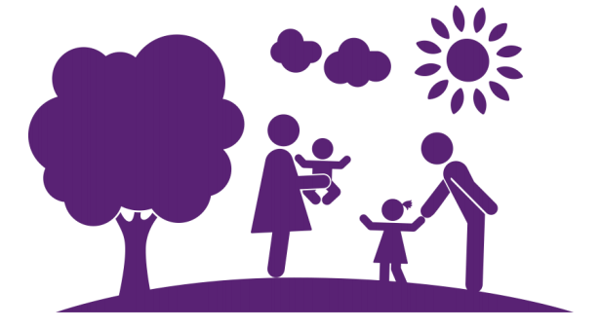

Question:

* How are disabled people, families and Whanau effectively achieving their goals?

Answer:

* 91% percent. This is 31 out of 41 people in the demonstration had completed at least half or more of the goals they had set for the past year.
* Some people said it was a slow process but they were still completing things.

EGL participants said:

* They felt they had much more independence in their lives.
* Had a chance to grow up and be independent
* Were able to be a contributor not a consumer
* Get on with life knowing that their home and personal care are looked after.

Some things families said:

* EGL has changed their lives
* They do not know where they would be without EGL
* Being able to do more activities at home and out of home has been great.

Tāngata Whaikaha and their Whānau

* Tāngata Whaikaha and Maori disabled people make up 36% of total people in EGL.
* Tāngata Whaikaha and Maori participants and families were happy with EGL and felt as if they were well supported.
* Families felt safe and that they could rely on EGL compared to other systems they had worked with.
* They stated they had positive relationships with their Tūhono/Connectors and they loved and appreciated that they were Māori. Stating that it makes a big difference
* Everyone loved the ongoing communication they had with everyone as well.

Tagata Pasifika and their Families:

* Tagata Pasifka make up 7% of total participants across EGL.
* Families said EGL creates a real difference to their lives.
* A big thing that helps them is the opportunities, choice and freedom the disabled people get.
* Most people achieved what they had set out to do.
* They said EGL was family focussed.
* EGL helped them find places where they belong and feel accepted.
* EGL helped them feel ‘normal’

Tuhono/Connector Relationships

* Each participant has a Tuhono/Connector that they work with.
* Participants have said that their Tuhono/Connector is someone that they trust and respect.
* People have said they feel supported and are able to ask for help when they need it from their Tuhono/Connector.
* People said they liked that their Tuhono/Connector helped them come up with new ideas and new ways to think about what they needed to live a good life.

Things that can Improve

* Having back up Tuhono/Connectors.
* Some people do not know what they can do with their funding.
* Some people are not having enough contact with Tuhono/Connector.
* People do not know of all their options that they have

This is what some of the family members have said about EGL:

* EGL is transformational … Power needs to be given back to the individuals with disabilities
* I thought how could it possibly change. I couldn’t see the light at the end of the tunnel, but now there is light all around me
* He is out in the community now. Before he was reliant on me, and if I was tired it wouldn’t happen…. I kind of have a life too

