ENABLING GOOD LIVES
WAIKATO DRAFT REPORT

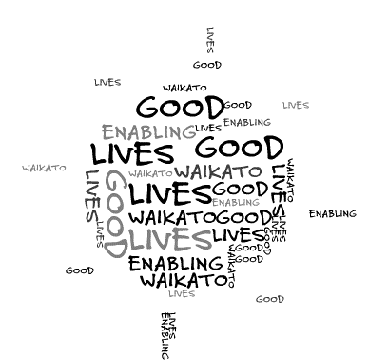

Compiled by Gordon Boxall and Mark Benjamin, August 2012
Contents
 | Page
Introduction | 3
Context | 3
Objectives | 5
Process | 5
Systems Change | 6
Establishing a Direction and Mandate for Change | 7
Families – Key Areas For Positive Change  A Way Forward – A Provider Perspective  List of Recommended Immediate Actions | 10  12  20
Appendices
- Enabling Good Lives – Foundation Principles | 22
- General Quality of Life Outcomes Framework | 23
- Examples of ‘Individual Outcomes Progress Recording’ | 24
- Disabled Persons Perspectives | 27
- Family/Whanau Perspectives | 28
- Establishing a Self Directed Individualised Support System | 30
- Increasing Focus on Natural Supports | 32
- Everyday Things in Everyday Places | 33
- Specific Staff Skills Associated with a Facilitation Based Support Model | 35
- Innovation | 36
- A Brief Profile of Involved Providers | 38

Introduction
Enabling Good Lives has quickly become something of a household term in the disability sector and, although it, as yet, is not part of government policy, it is understood that it is likely to feature centrally in the forthcoming Disability Action Plan. Starting as a working group on how disabled persons spend their day, it has become the focus of a much wider discussion about what needs to happen across the disability system to ensure people are enabled to have the opportunities to have a good life. Enabling Good Lives Waikato was initiated by a group of providers who all have contracts to deliver Day Services (funded by MoH) and Community Participation Services (funded by MSD). They sought more flexible contracts to enable them to align with the Enabling Good Lives principles and it was an opportunity for the Ministries to test whether they could integrate their funding and contracts to get better outcomes for disabled persons at no additional cost.
Context
On 1 August 2011, an Independent Working Group on Day Options presented the Minister for Disability Issues with a report entitled Enabling Good Lives. This report proposes moving away from centre-based daytime services to a facilitation-based support model built around individuals’ needs and aspirations, rather than around groups of people. The four elements of a facilitation-based support model, as described as follows:
- self-directed planning and facilitation
- cross-government individualised/portable funding
- strengthening families/whānau
- community building.
Enabling Good Lives proposes implementing the new approach incrementally and on an opt-in basis, and suggests that one of the best ways to begin is with innovative providers who are already interested in developing a more individualised approach and “ready” to make further service changes.
The Ministries of Health and Social Development then commissioned a separate project to test the applicability of Enabling Good Lives to the Earthquake hit Canterbury Region and to produce a Plan that showed how its principles and intentions could be realised over time. This Report, Enabling Good Lives, Canterbury was submitted to the Ministries on 30th June 2012.
Parallel to this process, a number of innovative providers in Waikato asked if Enabling Good Lives could also be considered for implementation in their Region and the Ministries asked Mark Benjamin and Gordon Boxall, who both facilitated the Canterbury process, to undertake a shorter, more focussed exercise involving two sets of meetings with key stakeholders. What follows is a report on the process and outcome

Enabling Good Lives Vision

A society that highly values the lives of disabled people and continually enhances their full participation

Enabling Good Lives General Purpose

To incrementally transition existing services to a facilitation-based support model. The focus of facilitation-based support would be on enabling disabled people to do everyday things in everyday places in communities, rather than on provision of ‘special’ places or activities for disabled people. It would include support funding from across government agencies that would be individualised and flexible

Enabling Good Lives, Waikato Project Aim

The aim of the project is to identify and demonstrate practical steps to move current day services (funded by Ministry of Health) and vocational services (funded by Ministry of Social Development) in Waikato towards the type of supports envisaged in the Enabling Good Lives report (and the Ministry of Health’s New Model for Supporting Disabled People).

Objectives
The intent of this project was to consult with disabled persons, family/whanau and selected providers in the Waikato to determine how:
- existing providers deliver supports in more flexible ways that enable disabled people to have greater choice and control over what activities they are involved in during the day
- disabled people in the Waikato will have increased participation and inclusion in mainstream activities and settings (according to their interests)
- there can be more flexible contracts that enable providers to build on positive changes they have made and move progressively towards providing individualised facilitation-based supports to disabled people
Process
Two sets of separate meetings were held with disabled persons, families and service providers on 25th and 26th June and also 6th and 7th August along with subsequent communication between these groups and the facilitators of this project. Some protocols were established at each meeting including agreement not to quote people directly, to respect the views of all people present and to seek consensus on any outcomes. A record of each meeting was circulated to participants for comment. The content in this draft was drawn directly from the meetings in the Waikato. Some parties requested information from the draft “Enabling Good Lives (Canterbury)” Report and this report was also circulated.
It may be worth noting some differences between the Canterbury and Waikato projects:
- The time and resources allocated were much less in Waikato to reflect this being a narrower and more focussed project
- Consequently, the views expressed were from those stakeholders directly affected and not necessarily representative of the wider sector or disability communities
- An observation of the facilitators was that, perhaps through the impact of the differences, providers could offer a stronger collaboration but disabled persons and families would need further support to ensure their voices could achieve at least an equal status to those of providers

Systems Change
It is critical to recognise that disabled persons, family/whanau and many providers emphasised positive development must occur within the context of a much wider and fundamental systems change.

This project did not explore the detail of the wider systems change. However, it was suggested systems change should include:
- a single place of “governance” that was a partnership between disabled persons, families, providers and officials
- a shared reference across Ministries i.e. principles, outcomes framework, development focussed evaluation, work plans and measures of success
- Designing a system where the person’s aspirations drive the process at all stages of life the need to explore a new process of “facilitation”, assessment and allocation of funding
- a focus on acknowledging and strengthening community networks and supports (not just a focus on the individual)

These points are consistent with points detailed within the “Enabling Good Lives Canterbury Report, June 2012”.

Establishing a Direction and Mandate for Change
Disabled Persons and Family Perspectives

“It’s all about respect and trust” (Direct quote from disabled person, 7 August 2012)

“People need to start listening (i.e. services) ...” (Direct quote from disabled person, 7 August 2012)

Disabled persons and families, involved with this process, widely endorsed the move towards facilitation based, community focused flexible services. There was general enthusiasm for achieving greater choice and control over both the supports and services they might access and wider systems change.
There was considerable emphasis placed on the perceived importance of change being “across Ministries”, removal of duplication, placing aspiration based personal planning as the central process and transparency. Emphasis was also placed, by disabled persons and families, on services interacting positively with personal networks (i.e. family and friends) not just ‘individuals’.
The only significantly different message given by families, in contrast to providers, was where the role of “life coach” (e.g. Independent Facilitator/Local Area Co-ordinator) is best located. Families were clear in expressing they felt they should be able to access this function independently of either provider organisations or NASCs.
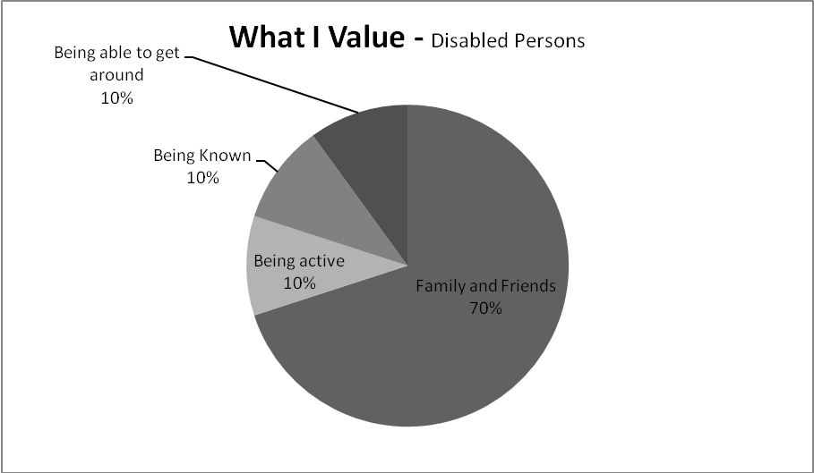
Note: These figures are an approximation based on comments made in two forums
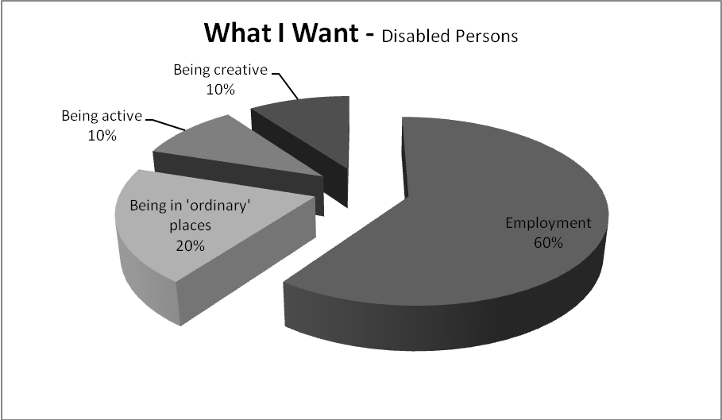
Note: These figures are an approximation based on comments made in two forums

What Would Make My Life Easier?
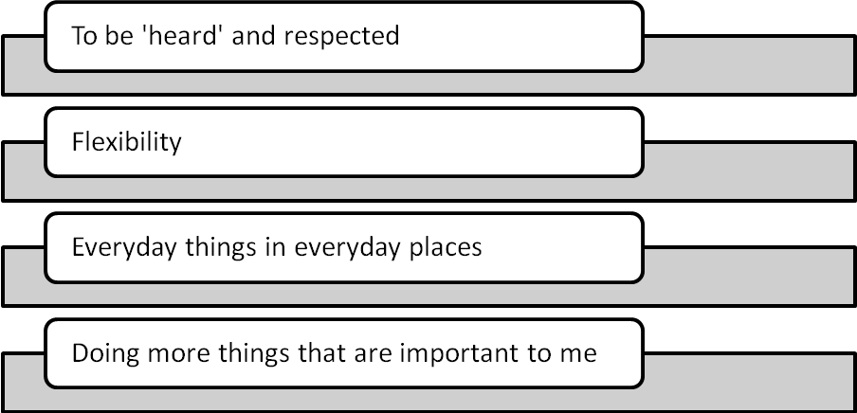

Families – Key Areas for Positive Change
Note: this reflects input from the families present during the consultation meetings and can not necessarily be considered representative of all of the perspectives of families in the Waikato
A Single Point of Reference | - Support for the "principles" contained in the initial Enabling Good Lives report being a foundation for all supports and services  - Support for the "General Quality of Life Outcome Measures" contained in the Enabling Good Lives (Canterbury) Report  - Support for one principles based, outcome focussed, evaluation process across Ministries and all services
The Role of a “Life Coach” | - Support for the development of an “independent” person who would be an ally to families, assist in whole of life planning and assist families in making choices regarding strategies, supports and services  - Funding would be aligned to the ‘personal plan’ (not service types)
Involvement in “governance’ type structures and forums | - Families clearly articulated a desire to support both a “person by person” approach and have influence over wider systems design and monitoring
Transparency | - Clear information regarding existing and potential funding processes to be made available directly i.e. not through service providers  - All options to be presented directly
Focus on ‘transition’ | - It was widely believed that it is critical for families to be linked as early as possible with someone in a “life coach” role  - It was believed to be essential to improve current “transition” from school services
Self Directed Individualised Funding | - All services become funded through processes where disabled person and families have maximum control over resources. Elimination of funding and “service type” silos
Partnership | - An investment to enable families to become informed and effective participants in service design and monitoring

A Way Forward – A Provider Perspective
The following key suggestions were promoted, by the selected providers, through face to face meetings, emailed submissions and informal discussions: These points were endorsed by participants at the Provider Forum on 6th August 2012.
- One set of clear principles are the foundation for all supports and services
There is a general agreement the Enabling Good Lives (EGL) principles, listed in Appendix One, could provide this framework. It is envisaged the principles form the basis of decision making across Ministries and services i.e. systems design, funding services, providing services and evaluating services.
Immediate Steps
The EGL principles are adopted as a basis for an integrated MSD and MoH contract for providing Day/Vocational services

To be considered:
1.a The EGL principles become the basis for systems design, funding services, providing services and evaluating services across Ministries at all stages of life

- A General Quality of Life Outcomes Framework can provide a basis for a joint MSD and MoH contract
There is general agreement the General Quality of Life Outcomes Framework set out in Appendix Two could provide this framework.
It is noted that the origin of this framework has involved the input of disabled persons, families and service providers. The current framework was an adaptation of material earlier published in the “:PREM III Checklist and Procedure” in 1987. The initial evaluation checklist was the culmination of nine years of evaluation work where disabled persons and family/whanau had key roles in the design and implementation of evaluation. In 2009, this framework was again reviewed by disabled persons, families and providers and has been used, over the last three years, in developmental evaluations for Vocational services funded by MSD and Support Living services funded by MoH.

Immediate Steps
The General Quality of Life Outcomes Framework is adopted as a basis for service development, monitoring and evaluation of Day/Vocational services funded through an integrated contract

To be considered:
2.a The General Quality of Life Outcomes Framework is applied across all services

- A Process of self evaluation against the “principles”, recording an individualised “shift over time” and associated support, can provide the basis for monitoring whether there is an effective use of resources
A primary measure of service effectiveness is the degree to which individuals and families are assisted to achieve better lives according to their stated aspirations and goals. This will vary from person to person and family by family. The key measure is ‘movement’/progress/results. While there may be a general quality of life outcomes framework, each service may engage individuals and families in a variety of approaches to achieve their goals and record success, adaptation and strategies.
Examples of the type of record that could be part of this process are included in Appendix Three
Immediate Steps
An integrated contract will require services to report to funders according to progress made in assisting people to achieve the outcomes they have described through various personal planning processes

To be considered:
3.a Individuals and families compile one personal plan and various supports and services report to funders according to their contribution towards assisting individuals and families to achieve their objectives.
Note: Aspiration based personal planning has been a feature of MSD funded Vocational services for the last decade. We note a new personal planning framework, that has been through a consultation exercise with key stakeholder groups in the sector, is to be trialled as part of the MoH New Model for Supporting Disabled People. There are many features in common between the existing MSD approach and the new MoH approach.

- Flexibility in how funds can be spent can be achieved when there is a focus on individual “outcomes”
Considerable discussion concentrated on how moving to a ‘person by person’ approach, with a whole of life focus, based on strengths, preferences and aspirations has the potential to achieve both shifting control (from the service to the individual and family) and flexibility. Services become crafted around personal networks, community assets and “making it easier” for people to achieve. Rather than individuals and families joining existing programmes or service types, services respond to unique circumstance and preference.
It became obvious this would ideally involve the removal of all ‘service’ limitations based on contracting for service type e.g. community participation, supported employment, supported living. In this environment, individuals would have an allocated “resource” and then identify how this resource would be best used to achieve their identified outcomes. This may include a diverse mix of supports and services.
Appendices Four and Five provide an overview of what disabled persons and family members separately identified as being most important to them in achieving a good life.

Immediate Steps
An integrated contract could include: removing current requirements around day services being 9 – 3pm; Monday to Friday, enabling providers to subcontract to each other for individuals supports, including all ‘service types’(e.g. supported employment, community participation) allowing MOH funding to be used to support individuals who are working towards/in employment and enabling providers to use funds allocated currently on a ‘unit’ basis (ie a unit = 3 hrs of day service) for 1:1 support, and/or a mix of individual and group based support.

To be considered:
4.a Including “residential”/supported living options.
- System change - Key elements of “systems” change that would result in greater flexibility of services, increased employment and security of supports and services include: having a single source of funding, building on existing expertise within services and developing trusting relationships
Immediate Steps
Develop a “leadership”/governance group comprised of disabled persons, families and providers who will consider wider “systems” change from a national and regional perspective i.e. what needs to be part of a nationally consistent framework and what aspects can adopt a regional approach

To be considered:
5.a All funding is channelled through an individualised process (one person-one plan with flexible resource.

Note. 1 It is recommended that a Personal Planning Framework such as the one recently developed for use in the MoH New Model for Supporting Disabled People Projects is adopted
Note. 2 Disabled persons and families are clearly expressing a desire to have more independence in being supported to have a good life. They see the need to have an ally who will work alongside them to navigate the ‘system’. The resources and skills to deliver these functions is currently sitting within NASCs and Providers and there is a tension for the former in terms of their need to allocate resources and manage budgets and also for the latter who, aside from fulfilling their mission to enable disabled persons to get better lives, only materially benefit if their services are purchased. When considering what a new system will look like, these issues need to be addressed carefully to ensure there is to be a smooth transition from one to the other. This is considered one of the most critical issues to consider. Appendix Six sets out one way it might be developed.
5.c Harness and acknowledge existing skills and experience, and local community knowledge regarding facilitation and (area) co-ordination
- Increasing a “focus on natural and community based structures/supports before specialist bases or services” be achieved when this is recognised as a priority, funding is attached to this and targeted training is made available

Immediate Steps
Collate and/or develop examples of processes, practices and resources associated with services having a primary focus on natural and community based supports/structures
Ensure services have access to values based staff education that is practical and is crafted to reflect a facilitation based approach

To be considered:
6.a Align generic sector training and qualifications with a facilitation based approach
Note 6.1: See Appendix Seven for some initial ideas about how natural supports can be developed
Note 6.2: See Appendix Eight for the practical skills/approaches required to make it easier for individuals to participate and contribute in the community.
Note 6.3: See Appendix Nine for an overview of skills, tested in New Zealand, directly relevant to increased social inclusion/contribution.

- Creating an environment where “innovation” occurs requires a trusting contracting process
Immediate Steps
The integrated contract describes the behaviours, of all parties, that will exist within a “high trust” contracting environment

To be considered:
Note 7.1: See Appendix Ten for the challenges that need to be overcome to achieve an environment within which innovation can succeed

- Increased employment opportunities can be achieved when funding is linked to an individual’s preferences and aspirations (not limited by contracts defined by “service type”)

Immediate Steps
Replace contracting according to “service type” or specified “inputs” with a personal outcomes approach (see 2,3 and 4)

To be considered:
8.a Explore the most effective way to include other ‘service contracts’ (e.g. supported living, residential services) within the “one person – one plan” process (also see 17)
- Effective transition from school to work can occur when families are supported as early as possible to see employment as a natural progression from education, transition support begins when the child is 13-14 yrs old and funding contracts enable a ‘whole of life’ flexible approach.

Immediate Steps
Review the effectiveness of current ‘transition’ arrangements between MSD, MoE, ‘transition’ providers, families and schools.

To be considered:
9.a Prioritising ’transition’ services for inclusion within an integrated contract between MSD, MoE and MoH

- Disabled persons and family/whanau can experience “increased control’ when they have key roles in systems design and services can become fully person directed via funding processes, staff skills and organisational flexibility.
There is general support for disabled persons and family/whanau to be involved in governance processes that operate across Ministries

Immediate Steps
Continue work with families and establish a core group who can liaise with providers associated with the “Good Lives” Project group

To be considered:

10.a Establish a Regional Governance/Leadership Group comprised of disabled persons, families and providers

- Safeguards should be developed person by person with appropriate regard for the ‘dignity of risk’.
Immediate Steps
Generic “risk management” practices, that may be required by current contracts, are replaced in an integrated contract with a framework that guides the development of “safeguards” on a person by person basis.

Note 11.1: There is a general belief that funding agencies and some associated monitoring processes have a disproportionate focus on perceived risk and “safety”. It is believed that this can limit options, restrict individuals and is a form of control.

- Providers involved in this project state they currently practice a ‘strengths based’ approach. Other practices, within the wider sector/system need to become aligned with the principles and practices associated with a strengths based approach.
Immediate Steps
The integrated contact reflects a ‘strengths based’ approach.

To be considered:
14.a All systems become aligned under a common principles base and governance structure.
Note 14.1: This would include the processes used for allocating funding and personal planning approaches
15. Evaluation processes are based on the Enabling Good Lives principles, the General Quality of Life Framework, an individual/family aspiration focus and service development
Immediate Steps
  - Adapt existing evaluation frames of reference so there is a single reference point explicitly based on the EGL principles
To be considered:
15.a All services, across Ministries, have a shared evaluation frame of reference and one evaluation process is used.
- Explore the role of “life coach” (Independent Facilitator/LAC) and its potential interaction with individuals, families and providers. This to include investigating how this process may enable expanded self directed individualised funding as a mechanism for funding/accessing all services
Immediate Steps: Gather a representative group of disabled persons, families and providers to consider the work associated with the Enabling Good Lives (Canterbury) and the MoHs “New Model for Supporting Disabled People”. Explore a framework for this approach in the Waikato

To be considered:
16.a Designing a national approach where access to services will occur through the new individualised funding/independent facilitator process

List of Recommended Immediate Actions

- The EGL principles are adopted as a basis for an integrated MSD and MoH contract for providing Day/Vocational services

- The General Quality of Life Outcomes Framework is adopted as a basis for service development, monitoring and evaluation of Day/Vocational services funded through an integrated contract

- An integrated contract is developed that will require services to report to funders according to progress made in assisting people to achieve the outcomes they have described through various personal planning processes. An integrated contract could:

  - include removing current requirements around day services
  - describe the behaviours, of all parties, that would exist within a “high trust” contracting environment
  - replace contracting according to “service type” or specified “inputs” with a personal outcomes approach
  - replace generic “risk management” practices, that may be required by current contracts, with a framework that guides the development of “safeguards” on a person by person basis.
  - Reflect a “strengths-based” approach
  - Adapt existing evaluation frames of reference so there is a single reference point explicitly based on the EGL principles

- Develop a leadership/governance group comprised of disabled persons, families and providers who will consider any ongoing operational issues from MoH and MSD that may have an impact on this area of work along with wider “systems” change from a national and regional perspective i.e. what needs to be part of a nationally consistent framework and what aspects can adopt a regional approach

- Consider how best to establish a self-directed individualised support system and how to transition towards it using Appendix 6 as the starting point

- Ensure services have access to values based staff education that is practical and is crafted to reflect a facilitation based approach. This to include: collating and/or developing examples of processes, practices and resources associated with services having a primary focus on natural and community based supports/structures as described in Appendix 7

- Review the effectiveness of current ‘transition’ arrangements between MSD, MoE, ‘transition’ providers, families and schools.

- Continue work with families and establish a core group who can liaise with providers associated with the “Good Lives” Project group

- Gather a representative group of disabled persons, families and providers to consider the work associated with the Enabling Good Lives (Canterbury) and the MoH “New Model for Supporting Disabled People”. Explore a framework for this approach in the Waikato

Appendix One

Enabling Good Lives – Foundation Principles

- Self determination - tino rangatiratanga: Supports/services are crafted according to expressed preference and aspiration
- Mana enhancing: values the contributions of disabled people and their families, and ensures support provided empowers them – ie support should be invisible, not diminishing mana.
- Whole of life: do not compartmentalise people’s lives (day, night, work, recreation) and focus on a whole life journey (eg preschool → school → post school) when planning and developing supports.
- An ordinary life: disabled people work, contribute, have relationships, a family or children, a home, take part in their culture and participate in recreation and sport like others at similar stages of life. Funding would facilitate access to everyday life in the community rather than separate facilities or activities for disabled people (but disabled people would still be supported to spend time with others if they choose).
- Mainstreaming: community based or generic supports should be exhausted before separate disability supports are provided (mainstream is the default).
- Whanau ora – empower families: Control is held by disabled people and families. Support families to imagine what a good life might look like and how this can be achieved.
- Kotahitanga tatou: a unified partnership that connects people and their family and whanau with communities and includes community development - engaging and supporting communities to be more welcoming and inclusive of disabled people.
- Simplicity: supports are simple, easy to access, begin early (timatanga), are the least intrusive and all supports make things easier for the disabled person.
- Timatanga (begining early): invest early in families to support them to be aspirational for their disabled child, to build community and natural supports and to help support their disabled children to become independent/ interdependent adults.
- Flexibility: to meet the continuum of need and be responsive to people’s changing needs and aspirations over time

Appendix Two - General Quality of Life Outcomes Framework
Area | Individual Outcomes – in relation to contact with supports and services
Autonomy  (Self determination) | - Individuals believe the service tries to understand them.  - Individuals have control over their lives.  - Individuals make informed choices e.g  where they live,  who they live with,  opportunities for employment, involvement in their community and access to relevant education and training
Natural Authority  (Control over services) | - Individuals have a range of opportunities to influence policies, practices and activities in the service.  - Individuals contribute to the regular evaluation of services.
Identity  (Personal Development) | - Individuals are encouraged to develop and express their identity.  - Individuals have opportunity to explore their personal growth and are able to imagine and strive toward a truly good life.  - Individuals experience fulfilment in their lives.  Individuals’ personal information is regarded as confidential.
Belonging | - Individuals participate in a range of educational, social, recreational, employment and/or personal activities in the community.  - Individuals are connected with supportive natural networks.  - Individual are able to contribute to the community.  - Individuals have a range of roles that are socially valued.
Customised Supports | - Individuals experience resources and supports that are customised to meet their expressed aspirations, preferences and needs.  - Individuals experience the service as encouraging and enabling.  - Individual experience that achieving their aspirations is easier through contact with the service.
Opportunity | - Individuals experience opportunities for gaining new skills and qualifications and economic advancement  - Individuals contribute to the community.
Partnership | - Individuals and significant others are respected as partners.
Safety | - Individuals experience the service as reliable.  - Individuals are safe.  - Individuals are supported to take risks.

Appendix Three
Examples of ‘Individual Outcomes Progress Recording’
- An Example provided by SAMS (A Vocational service supported to move to a facilitation based approach – no additional funding))
 | Before - i.e. April 2011 | Now – i.e. April 2012
Person A | Employed (PT) at a local fast food business but felt socially isolated | - Retained employment  - Volunteer teacher assistant one day a week  - Made new friends (invited to staff gatherings etc)  - Goes with friends to have coffee
Person B | Participated in centre-based activities 4 days a week | - Involved with local community craft group once a week – attends without support  - Exploring where to sell some crafts  - Had “Super Grans” come to her home to teach her how to cook – then went on to be a “Super Gran” and visit others  - Made new friends and now goes to movies and shopping with them
Person C | Participated in centre-based activities 4 days a week | - Volunteers at a cultural group to prepare lunches each week  - Assists in preparing and distributing lunches to the elderly  - Attends local gym  - Travels independently  - Goes out with friends of an evening (not something that occurred before)
Person D | Participated in centre-based activities 4 days a week | - Attends a community based CPIT computer course  - Goes to the gym on their own  - Attending a community pottery class
Person E | Participated in centre-based activities 4 days a week | - Participates in community dancing class  - Participates in community knitting group
Person F | Participated in centre-based activities 4 days a week  Paid job one weekend day | - One day a week volunteer job at YMCA (has won volunteering award for this)  - Fitness classes at YMCA in own time ; Spin, Zumba  - Weekend activities now include bowling team, fitness classes, socialising (with new friends) and working  - In November, shaved his head for cancer fundraising (and used his own networks of over 20 people to raise more than $850)
Person G | Participated in centre-based activities 5 days a week | - Working Monday and Friday  - Tuesday's - an all day event in Kaiapoi every week dismantling and rebuilding a derby car  - Art course all day on a Wednesday  - At service – Thursdays
Person H |  | - Career aims clarified, volunteer position cleaning cars found  - Increased contact/partnership with extended family
Person I | Participated in centre-based activities 4 days a week | - Walk group  - Arts and crafts group  - Line dancing group  - Evening singing and Maori performance group.  - Attends Skillwise three half days.
Person J | Attended centre-based activities 3 days a week | - Travels more independently/flexibly, allowing inclusion in a wider variety of activities  - Community gardening group

- Adapted from an example provided by Interactionz
Person we serve | Then | Plus facilitation | Now | Next steps –  6-12 months
“A” | “A” lacked confidence and had mobility issues that inhibited her participation in community. | - Discovery of aspiration (through process facilitation) to volunteer at the food bank  - Establishment of goal to connect with the food bank  - 1:1 goal facilitation to catch the bus, to build relationships with the food bank staff, to learn the allocated role, and to work towards independence | “A” volunteers weekly at the Hamilton food bank and is exploring other opportunities to contribute as a volunteer. | “A” will be catching the bus independently to the food bank and have a volunteer/natural support to support her in her role there. “A” will also have another volunteer job elsewhere in the community.
“B” | “B” was “unmotivated” and spent his days lying around at the community centre | - Discovery of the aspiration (through community exploration and conversation) to visit the local tavern to buy a coke  - Establishment of goal to “become a local at the local” and develop relationships with hotel staff and other locals  - Small group goal facilitation to visit the tavern weekly with other people we serve who enjoy the same environment  - Communication with the residential service for Harry to have money to participate in this activity | “B” has a weekly visit to the tavern with a goal facilitator and other people served by Interactionz, and he is getting to know people on a first-name basis. | “B” will be visiting the tavern weekly with a natural support. “B” will continue to explore other opportunities in the community that he is motivated to participate in.
“C” | “C” is a young man who spent his whole week based at the community centre. “C”wanted to be in paid employment and have his own money. | - Discovery of aspiration (through process facilitation) to find paid employment  - Establishment of goal to develop car valet service  - Small group and 1:1 goal facilitation to develop vocational skills  - Referral to supported employment provider  - 1:1 facilitation to catch the bus to his new workplace  - Facilitated connection with Kaumatua  - Facilitated meetings with “C”s caregivers and funding organisation to engage them in “C”s aspirations. | “C” established a successful car valet service and explored the responsibilities of self-employment including client booking and tax. Last month “C” achieved his goal of gaining part-time paid employment. He spends his afternoons at the community centre and is an important contributor to community centre life including developing his leadership skills in Powhiri/Whakatau/  Poroporaki | “C” will be maintaining his employment and travelling independently to and from his workplace.
“D” | “D” wanted to go horse riding but there was insufficient staff resource to do this 1:1 activity regularly and a volunteer had not been found | - Discovery of aspirations (through process facilitation) to go horse riding and maintain contact with a friend from another service  - Establishment of goal to go to RDA with his friend from another service  - Collaboration with another vocational service to share transport to RDA  - Circle member engaged a family member to be a natural support for “D” | “D” has been horse riding with natural support | “D” will be regularly going horse riding with his natural support.

Appendix Four
Disabled Persons Perspectives
During the Enabling Good Lives (Waikato) consultation process disabled persons emphasised
- The most important things in our lives are:
- Family
- Friends
- Being active – something interesting to do
- Being “known”
- Being able to get around e.g. transport, wheelchair

- What we value most about “services”:
- Having a place to ‘contribute’ e.g. helping other people, being a coach
- Trying different things e.g. being occupied, busy, recreation and voluntary work
- Being active e.g. cooking, fishing

- What we would change:
- 50% stated – ‘get a job/employment/meaningful work’
- More flexibility e.g. use pictures for cooking or going to the beach for fishing (there are no fish in the river where we go!)
- Do things in ordinary places e.g. a lack of transport makes it hard to do everyday things in everyday places
- Doing more things that are important to me (not what is offered)
- Being able to have gone from school into work (transition). Other people got help to do this but I didn’t.
- Not have to “fit the criteria” e.g. I wanted help to get a job but was told that I didn’t fit the criteria for support to do this and I needed ‘Community Participation’ – I had to find my own job (they had been successful!)
- Staff to listen better e.g. they always make suggestion about what I should/could do – it should be the other way around
Appendix Five

Family/Whanau Perspectives
During the Enabling Good Lives (Waikato) consultation process family/whanau emphasised:

- There is value (it is imperative) for the governance of any change process to be outside of particular Ministries

- It is critical for family members and disabled persons to be involved in governance

- There is a fundamental need for systems change

- ‘I want better services, I don’t want to have my family members care/quality of life to be my life’s work – I need to be able to trust services’

- The most important thing the system (and services) can do is learn to be responsive to the preferences and expressed desire of disabled persons

- Services seem preoccupied with “safety”. There are better ways that technology can be used so face to face support is more focussed on quality of life – not safety.

- ‘Safeguards’ need to be personalised – everyone needs a different approach

- The best system will be when the funding goes with (is controlled by) the individual and their family

- Flexibility is critical

- It would be good if support staff/organisations learned how to “facilitate” (not control) and for there to be a ‘strengths based’ approach (not needs assessment)

- Services need to learn how to “listen” and “pay attention” to family/whanau

- There was general discussion indicating some families do not believe services are currently ‘delivering what they are funded to do’ e.g. mostly having a group approach (not individual) and there appear to be limited and predetermined options (not built from what individual express they want)
- Although fundamental change is supported, there is a fear that any changes may result in less resources being available

- Families expressed that they were “hopeful” that change can be made

- There is the need for communication processes where information goes directly to families – not through service providers

- Building “trust” will be key to any changes being successful

- Families believe there is value in compiling a range of ‘scenarios’ that describe/illustrate what “real choice” can look like

- There is high expectations that “Enabling Good Lives” can be a catalyst for positive change

- It is important to link things together e.g. support, housing, transport etc

Appendix Six
Establishing a self-directed individualised support system and how to transition towards it
- The components of a self-directed support system
In a system that was self-directed (by the disabled person and their family) and individualised there might be a 6 step process for accessing information and supports that are provided by government:
- Access to information that applies to the nature of their disability, support networks and how the system work to support the individual and family throughout their life
- Ability to access a transparent “self assessment” process (with or without support). This process could be website based and would provide an “indicative funding” amount. This would vary considerably according to circumstance.
- Access to support from a Facilitator (possibly a Local Area Coordinator, Navigator or Life Coach) to develop a life plan which might include, based on knowledge from the above information, a need to access supports beyond those currently available to the person i.e. possibly beyond natural supports and existing community services
- Funding is confirmed i.e. the plan and associated costs reviewed by a funder, appointed by government, to establish whether there is a need for paid supports to be available to meet any shortfall in the person’s own, their family’s or other natural supports to achieve the ambitions in their plan. Funding is confirmed where this is consistent with what government identifies as being in line with the principles of its disability strategy
- The disabled person and their family choose which paid supports to purchase and have control about how they are delivered and reviewed
- Ongoing support from the independent Facilitator/Coordinator to enable the Plan to be monitored and reviewed with the funder and provider - as directed by the disabled person and their family and the conditions associated with the level of funding obtained

Appendix Six (continued)
- Transition towards the new system

Some of the roles described above have been taken on by providers for legitimate reasons i.e. to support better person-centred planning and support processes. For some disabled people this might prove to be the best option as the provider knows them well and can assist people to build good plans and raise their aspirations by, for example initiating new activities. It should also be noted that without providers taking the initiative (particularly as this is unpaid) this couldn’t have progressed at all for people receiving services. However there is an obvious tension if providers are the only option for people particularly as they naturally has a vested interest in the person continuing to receive supports/services from them.

NASCs also have a key role currently to assess and support people to access the most appropriate supports and services. Their challenge to do this is two-fold; first in terms of their ability to provide the in-depth personalised facilitation that focuses on natural and community supports with paid supports being the last resort; second, this is combined with considerable pressure regarding budgets from MoH and a requirement to adhere to wider bureaucratic systems that whilst not geared to individualised processes or outcome measures do take considerable resources to ensure compliance. Again, there is a conflict (albeit not of their making) between their desire to be an ally to the family with their requirement to gate-keep resources.

With disabled persons and families requesting some assistance that is independent, of both providers and NASCs, it is proposed that resources be freed up to enable this to happen. In line with the Canterbury Report, this is proposed to be through separating out the funding function, which will presumably remain with NASCs, from the Facilitation function which could, for example be provided through a separate entity in line with the likely outcome of the Local Area Coordination approach. The detail of how this would be achieved would need to be carefully considered and may evolve incrementally with, like Canterbury an initial focus on one discrete group, like in this instance the people funded for day services, could be beneficial whilst the sector reorganises its contracts, systems and structures in line with this and with regard to the wider system transformation process.

Appendix Seven

Increasing focus on “natural supports”

Some key points:
In order for more disabled people to be able to undertake ‘everyday things in everyday places’ paid services need support to be more outward looking and mainstream communities need support to be more accessible and inviting. This is not likely to happen ‘naturally’ so though needs to be given to how this can be initiated and sustained. Waikato providers have given attention to this with some good successes. However, they also recognise that more needs to be done with a shift in culture required for all parties. There follows some early thoughts about how this could be developed

There is therefore recognition that this needs to be an area of focus

One approach would be for Facilitation providers to receive some funding, so that they can engage with the individual, work with them on their aspirations and goals, and develop a facilitation plan that then enables exploration of natural and community based supports. It is considered this would be in the vicinity of $2000 per person, where family are unable to take this responsibility. Current providers could be funded to do this work in the first instance.

It is acknowledged some providers already have some very good networks with the communities in which they operate.

Volunteer recruitment and management positions will become necessary as unpaid supports grow.

An investment in training for organisations to learn about the intricacies of community building
An investment in public education so that natural and community based structures and supports exist.
The local governance group could incorporate ‘non-disability sector community leaders as part of its mandate

Appendix Eight

Everyday things in everyday places
Considerable work has been successfully undertaken in New Zealand to identify the practical skills/approaches required to ‘actually make a difference’ when making it easier for individuals to participate and contribute in the community.
How will a facilitation-based support model make a positive difference?
The following material has been adapted from “Effective Practice in Community Participation Services: A New Zealand Experience”
What | How this is done?
- 1. Assist the development of trusting relationships | - “making the time” to learn about an individual’s preferences, strengths and goals  - Becoming familiar with an individual’s natural supports (family/whanau and friends)  - Ensure that the individual moves at their own pace  - Respect people’s space
- 2. Structuring opportunities for people to succeed | - Expose individuals to lots of different opportunities and experiences – then find out what interests/excites people. Give people things to do that they can be successful with - then encourage them to choose what they will do  - Break big things down into smaller steps and identify who will do what  - Encourage/acknowledge  - Highlight peer achievements
3. Assisting individuals and families to “take more control” | - Discussions where people determine what they want to be involved in – individuals experience that their opinions immediately translate into service actions  - Encourage participation by sharing responsibilities  - When a trusting relationship has been developed, deliberately shift responsibility i.e. you want it = you do it  - Atmosphere characterized by a mix of respect and mutual “joking” i.e. not “therapeutic” but fun!  - Staff awareness of “power and control” dynamics”
4. Increasing knowledge of what exists | - Know what is “out there”  - Link individuals/groups with the right person/activity/group in the community (not duplicating/replicating or creating a “special” version  - Reflective practice i.e. what did you learn from that?, what can we do differently next time?  - Adapt approaches and activities for each individual and situation
5. Creating a clear vision and purpose | - Shared “principles” as a foundation  - Shared “outcomes”  - negotiate on an ongoing basis.  - strong values base
6. Affirming or developing strong leadership | - Ensuring leadership “style” embody the values and principles associated with Enabling Good Lives  - meaningful conversations with all involved parties
7. Finding out what people want more effectively (see “personal planning section”) | - Casual conversation and observation are the key
8. Individualised Service Delivery | - ask the person what they would like a build services around this
9. Increased Partnerships | - Working collaboratively  - Constantly looking for opportunities outside of disability sector – focus on community
10. Expand a “broker role” | - linking people in to outside opportunities  - “out of hours” support  - Assist people in “joining the dots”
11.Strengthen the “Interpreter” Role | - Paying close attention to what individuals are expressing, through actions, reactions and discussions
12. Expanded good relationships in the community | - Location – right in the middle of things  - Network  - Help people with the change process  - Restore, develop or affirm good relationships with families  - Become a community asset

Specific skills/approaches central to assisting individuals to experience “everyday things in everyday places”:

Talking mats | Circles of friends | Community mapping
Mind mapping | “Tasters” | Identifying roles
Increased contact with family | Values and principles based staff education | Increased expectation

Appendix Nine - Specific staff skills associated with a facilitation-based support model

- Interpersonal Communication Skills
- Creating safe environments
- Open questions
- Perception Checking (understanding accurately)
- Positive Reframing (turning ‘problems’ into possibilities)
- Variety of communication techniques (e.g. ‘talking mats’)

- Conflict Management
- Win/win concepts and practices (negotiation skills)
- Meeting conflict constructively
- Appreciating diversity

- Networking
- Local knowledge (e.g. community mapping, asset registers)
- Developing relationships i.e. family/whānau, generic resources and allied social/human services

- Strategic Planning
- Environmental analysis
- Task Analysis i.e. breaking things down into achievable steps
- Asset development e.g. community, person, staff, family and systems

- Matchmaking
- Developing connections

- Cultural Competency
- Informed and respectful ways of working

- Optimism
- Strengthens Based Practice
Appendix Ten

Innovation
Key points
One significant area that has consistently been raised through this process with the compilers of the report is a sense that innovation has been stifled in the MoH system. In spite of the ambition which desires a shift in power towards disabled persons and families, the main focus has apparently been on contract compliance and budget control. Innovation is therefore undertaken ‘under the radar’.
Where innovation is supported by MoH staff it has to fit into one of the current service types however irrelevant, In one way this is how Waikato services have evolved as they have with innovative and resourceful providers pushing the boundaries to enable disabled people to have access to a wider range of resources than is typically the case (for example in Canterbury).
It is considered that until initiatives like Enabling Good Lives and the New Model for Supporting Disabled People move from the margins to the centre of Disability Support Services then their effectiveness will be partial and possibly undermined by the day to day work programme.
Innovation has risks which is why it needs to be considered openly and transparently so they can be assessed and managed with lessons learned on the way. Without innovation the system will continue to do what it has always done and is therefore likely to get the results it has always had.
As with Canterbury, whilst there are different views about how to go about doing things differently, there is a lot of common ground between stakeholders about what is needed. This has been identified as both service change and system transformation. These changes will require innovation to be encouraged and rewarded.
Innovation:

- largely down to individual organisations and leaders within those organisation being prepared to “have a go” – value of courage

- an investment in knowledge acquisition – we can learn a lot by exploring other models – not just in disability sector

- an acknowledgement, by funders, that sometimes we will try things that don’t work i.e. don’t punish the innovators. Finding out what doesn’t work is as important as finding out what does.

- allow providers to use funding creatively – so criteria set are broad brush, and enabling.

- requires a degree of freedom to explore, and trial things. Note: It is believed by some providers that the latest draft of the potential MOH contracts out for consultation at present, completely squashes any thought of innovation, trust, or positive environment for change.

- works best if it happens as a partnership with trust and collaboration offsetting risks and challenges. The governance proposals, suggested in some Enabling Good Lives materials, would assist this immensely

Appendix Eleven
A brief regarding the six organisations engaged in the “Enabling Good Lives Waikato” project and the independent ‘Good Lives Waikato Project’

Community Living – Live the dream. Tell the story

In August 2012, Community Living Trust will celebrate 23 years of success in supporting people with intellectual disabilities. Since its inception in 1989, Community Living Trust has persistently sought innovative and diverse ways to respond to the individual needs of people with intellectual disabilities (with autistic spectrum disorder, multiple disabilities, high & complex behaviours and offending histories) within their communities in the Waikato, Bay of Plenty, Taranaki and greater Midland region.

Our inspirational dream of “People with intellectual disabilities living their dreams through community connections” defines our strategic direction underpinned by our beliefs and values.

Based in Hamilton, Community Living and its partners now support more than 700 individuals of all ages via a range of services:
- Behavioural Assessment and Support services,
- Occupational and Physio Therapy services,
- Family Living Options i.e. Home Based Support services, Shared Care Family services, Contract Board Family services, Coordination services, Respite services for young people and adults. Disability Liaison
- Vocational services i.e. day services and community inclusion activities
- Flatting, Residential and Regional Intellectual Disability Supported Accommodation Services (RIDSAS) and offender rehabilitation services.

We are committed to the “Enabling Good Lives project” in collaboration with all the stakeholder groups to actively work together making a difference in people’s lives.

Gracelands Group of Services. A life like any other.

Gracelands Group of Services is based in the Waikato, with the service centre in Te Awamutu. Gracelands covers a wide geographical area of the Greater Waikato, from King Country to Thames, New Plymouth and Paeroa. Services include but are not limited to community participation, employment focussed services, rehabilitation services and a private training establishment delivering TEC and MSD funded courses.

The core to Gracelands Group of Services is people with disabilities. Our purpose is to work alongside individuals to develop their skills and abilities and enhance inclusion in the communities of their choice. The ultimate goal is to assist individuals to have the life they desire in the community - and to be in the driving seat. Our services on offer are expanding, to ensure greater choice, control and flexibility.

Gracelands recognise open employment as the best possible employment outcome in ensuring people with disabilities are included in the communities of their choice. All of Gracelands employment related services will work towards assisting people who want employment, into open employment.

While disability is our core business, supplementary to this is education to people who are disadvantaged. There are many commonalities between these two broad groups of people, and the work that we do with disadvantaged young people, can assist in our service development and delivery to people with disabilities.

Working with other organisations Gracelands will be strengthened and greater specialist knowledge can be sourced. Development of partnerships and alliances will add academic rigour, and help us to support a wider group of people with disabilities than we currently support.

We believe that our commitment to the people we support, their family / whanau, working together and developing partnerships with other providers, communities and education will add value to the Enabling Good Lives Project and ultimately outcomes for people.

IDEA Services

IDEA Services provides support for people with an intellectual disability so they can live, learn, work and enjoy life as part of the community. Our services include day services, a range of accommodation services, supported living, supported employment, home support and services for family/whanau. People are at the centre of what we do, with our values of Empowerment, Inclusion, Support and Responsiveness always guiding our passion to see every person who has an intellectual disability achieving their dreams.

IDEA Services is the service arm of IHC Incorporated, an association with a history reaching back over 60 years which advocates for the rights, inclusion and welfare of all people with an intellectual disability and supports them to live satisfying lives in the community.

IDEA Services is excited to be part of the team working on the Waikato Enabling Good Lives project. Working with the other providers as a part of our community we can build relationships and develop a more collaborative approach to supporting people to lead fulfilling lives. With so many positive changes on the horizon in the disability sector we are looking forward to being part of a group working towards change that will enable more choice and opportunities for people with disabilities to lead better lives.

Interactionz

Interactionz was established in 1967 and in its lifetime the organisation has been known by several names, and done many different activities. The one thing that has remained the same over time is the intentionality of our work to make long-term, positive and sustainable difference in the lives of the person’s we serve and the communities we belong to.
Our vision statement represents the highest potential for the future of our community and is a statement about how we want our community to look.
‘People leading lives that have meaning to them, with infinite possibilities’.

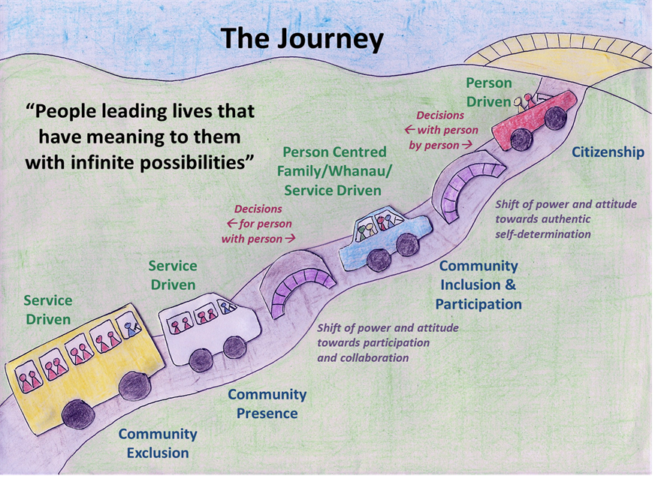
While our work is primarily with persons with disabilities, our vision is about community. Our vision requires a community where everyone is living their lives in ways that are meaningful to them, and where they are open to all possibilities. It is only within a community such as this that persons with disabilities will achieve lives of meaning to them, and become valued citizens with the right to participate and the responsibility to contribute.

Life Unlimited

Life Unlimited is based in Hamilton and works in a wide range of ways with people with disabilities, their families and support people in the Waikato and in services delivered throughout New Zealand. Our vision is ‘Living independence for everyone’.

Life Unlimited is a provider of NASC (needs assessment service coordination) in Hutt Valley and Tairawhiti, and of Disability Information services in the Waikato, Bay of Plenty, Lakes and Tairawhiti. We have a keen interest and engagement in realigning these service models with new ways of working and walking alongside people.

Our services in the Waikato region are focussed on supporting and developing people’s skills and opportunities to increase their active involvement in the community. We welcome the opportunity to work alongside the group of Waikato providers committed to developing practical alternative approaches to enabling people to have good lives.

Progress to Health

Progress to Health is a community-based organisation providing mental health and disability support services.
Vision: “Communities with no barriers”
Mission: ‘To bring this vision into reality, we will reconnect individuals with their communities’

We were established in Hamilton, April 1995 and operate throughout the Waikato, Taranaki and Taupo regions with Head Office in Hamilton. We are funded manly through government agreements and looking to develop independent income streams. We have around 25 staff and our Executive team holds 30 years combined service.

Our service is based on 17 years’ experience of working with people with mental health and other disability issues, most of whom have also experienced long-term unemployment. We create a proactive, supportive environment which encourages each participant to “maximise their potential”. Our philosophy is that a person moves through our services, improving or acquiring skills and abilities to achieve their aspirations. In addition, we work with the philosophy that the moment a client enters our service, we are working alongside them to exit it.

The strengths of the service are:
- strong leadership by the governance and the management of the agency
- committed staff teams with strong local connections and knowledge
- the confidence and willingness to make changes to the way a service is operating to improve the outcomes for the people using the service.

Progress to Health supports and identifies the need for a collaborative, centralised approach for services in order to improve participation of people with disabilities in employment, their communities and society in general.

In order to be successful in this, when listening to individuals’ goals and aspirations it is through identifying the natural supports available (i.e. family/whanau, friends, community) and a collective agreement to break the goal down into small achievable bites, taking care not to “burst the bubble” of the original dream.

