Enabling Good Lives
Key messages

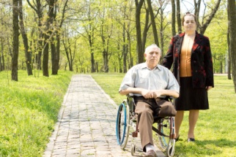

Easy Read Information
About Enabling Good Lives

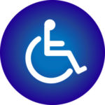
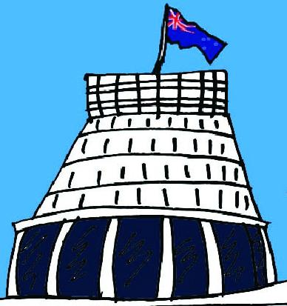
The Government and the disability sector of New Zealand are working together to change the way disabled people and their families/ whānau get support.

Disabled people should be able to have good lives like everyone else.

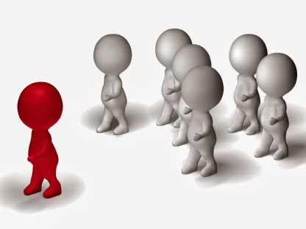
This means having:
- choices about what support you get
- control over your own life.

A 3 year project called Enabling Good Lives has started in Christchurch.

It is about trying out a new way to provide disability support.

This will show disabled people, the Government and disability support services what a new system could look like.

Enabling Good Lives is not a step-by-step plan of how to do things.

Enabling Good Lives tells services:
- why change is important

- what are some of the ways that support can be done differently

- what life could be like for disabled people in the new way of doing things.

It is hoped that disability support in the future will be right for every:
- person

- family/whānau

- community.
What has been done so far?

January 2009
The Government started to look at problems in the disability support system.

A group was put together to do this work – it was called the Ministerial Committee on Disability Issues.

June 2011
The Enabling Good Lives report came out.

The report said that the way disability support is done in New Zealand needs to change.

Disabled people need more choice and control.
June 2012
The Enabling Good Lives in Canterbury report came out.

Disabled people, families/whānau and services helped to write it.

The report showed how to change the disability system in that region.

August 2012
The Enabling Good Lives Waikato report came out.

Disabled people, families/whānau and services helped to write it.

The report showed how services in that region can make changes to the way they work.
September 2012
The Ministerial Committee on Disability Issues agreed to change New Zealand’s disability support system.

The new way of doing things will be based on the values of the Enabling Good Lives reports.

July 2013
The Government decided to do a 3 year project in Christchurch called Enabling Good Lives.

It will try out the new disability support system.

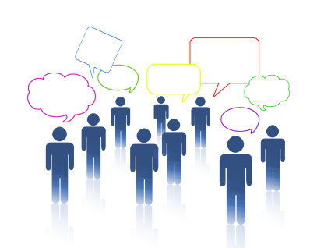
July 2013
A group called The Enabling Good Lives Leadership Group was made.

This group has 2 jobs:
- to make sure the project sticks to the values of Enabling Good Lives
- to give the Government advice about the project.

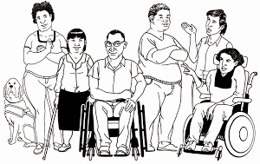
August 2013
A group called The Enabling Good Lives Local Advisory Group was made in Christchurch.

In the group there are:
- disabled people
- family/ whānau members
- people who work in the disability sector.
What are the key messages of
Enabling Good Lives?

The next few pages will tell you the key messages of Enabling Good Lives.

Key messages are the most important parts of the project to know about.

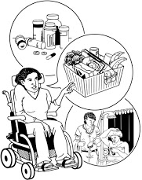
Control
Disabled people and their family/whānau should have control over:
- how their funding is used
- their own lives.

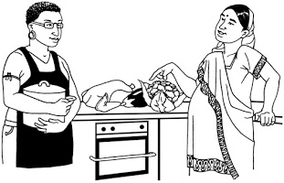
Disabled people are not all the same
People have different:
- cultures
- beliefs
- ways of living.

People who support disabled people need to be able to change how they work to suit each person and their family/whānau.

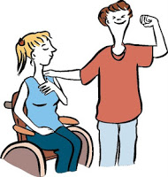
Family/Whānau
Family/whānau is one of the most important things in people’s lives.

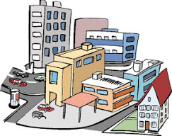
Different communities
Life in New Zealand is not the same everywhere.
For example:
- some people live in cities
- some people live on farms
- Some people live in small towns.

The new system will look different in different parts of New Zealand so that it works for everybody.

Community
Services will help disabled people to be part of their community and use community supports.

More choice
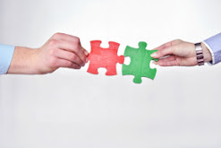
Enabling Good Lives will mean disabled people have:
- the choices they already have about their support
- more choices open to them.

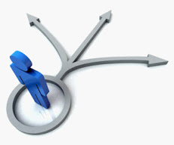
Change
Enabling Good Lives is about changing:
- the disability support system
- the way services do things.

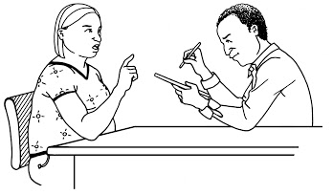
A new way of doing things
For disabled people and family/whānau to have real choices and control, the whole disability system needs to change.

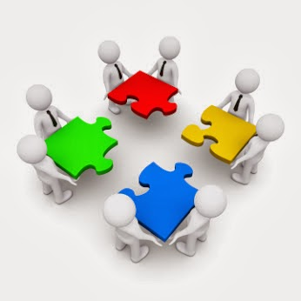
Working together
Disabled people and their family/whānau have said that government departments must:
- work together better
- all have the same rules.

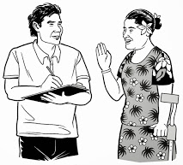
Disabled people must have a say
In the groups that are in charge of setting up the new system there must be:
- disabled people
- Disabled Persons Organisations
- family/whānau.

Individualised Funding

With the new system, disabled people and their family/whānau will have control of the funding.
Government departments will put the funding together so that disabled people get one lot of funding.
Changing who does what
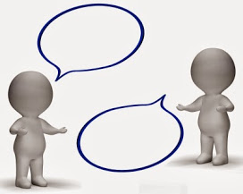
The job of Needs Assessment and Service Coordination organisations (NASCs) will change.

The job that NASCs do now will be done by 2 different places.
- The 1st place will do assessments on disabled people and say how much funding they can have.
- The 2nd place will help people and families/whānau to find the right services and support for them.
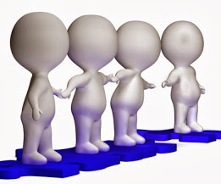
Helping people do things for themselves rather than doing it for them
Disability support services will help disabled people and their family/whānau to have good lives in the community.

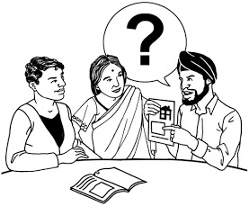
A better way to do things
The goal of Enabling Good Lives is to make services and supports better for disabled people and their family/whānau.

Why is Enabling Good Lives different?
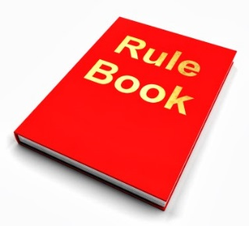

Enabling Good Lives is different because it means that:

- disabled people will be in control of their own lives.

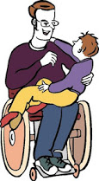
- services should start supporting disabled children and their family/whānau from when the child is very young

- the kind of support every person gets needs to be right for them.

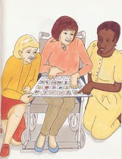
- disabled people should have ordinary lives with choices about:
  - learning
            - work
            - having a home
            - having a family
            - being part of the community
            - having friends or a partner

- when disabled people are choosing what they want to do, they will be supported to 1st use community services and 2nd services just for disabled people

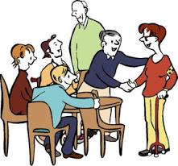
- disability support services must be easy to use

- disability support services will help people and family/whānau to be connected to community

- disabled people and their families/whānau have Mana.

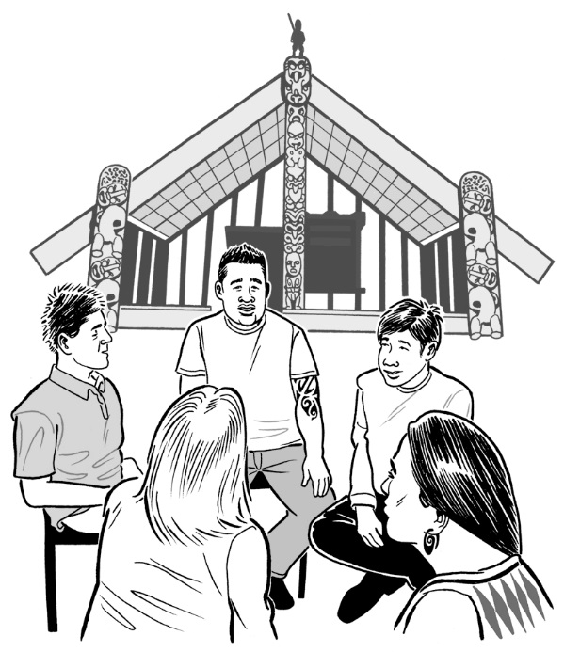
Mana is about:

- being respected for who you are
- your beliefs
- your family/whānau
- being respected for knowing what you want and how you want to lead your life.

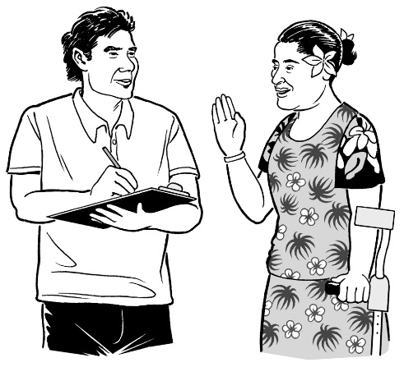
Support people need to know about you and listen to what you want your future to look like.

The goals of Enabling Good Lives

The next few pages will tell you the goals of Enabling Good Lives.

Goals for disabled people and families/whānau

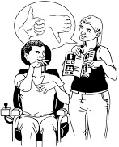
- To have more control.

- To get services and support that help people to have a good life.

- For people to have 1 plan.

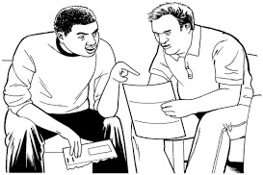
This plan will be based on what people can do and what they want to do.

All of a person’s supports will be based on the 1 plan.

- To have control over the funding.

The funding will all be put together in one place for people to use.

Funding can be used for things people need in their lives.

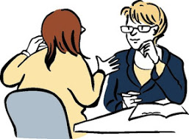
- Disabled people and their family/whānau will work with an Independent Facilitator called a Navigator.

The Navigator will talk to disabled people about what a good life means for them.

People will be able to choose how much help they get from a Navigator.

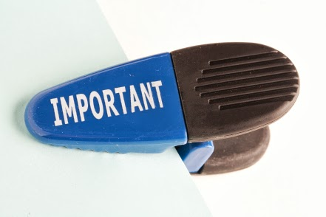
Important:
A Navigator will not say how much money people will get.

- To have more choice.

Disabled people and their family/whānau will be able to choose if they want:

  - to look after their funding themselves and buy support from services

or

  - to look after some of their funding themselves and use it to buy support

or

  - to give the job of looking after their funding to someone else.

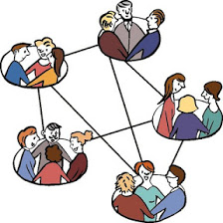
- To be able to talk to other disabled people and their family/whānau about the new system.

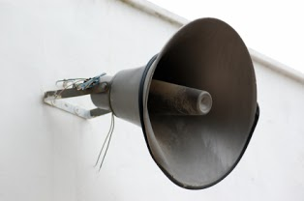
- To have a say in the running of support services.

- To be asked by services:
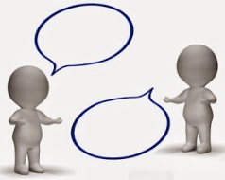
  - if the service is doing a good job
  - how they can do better.

Goals for support services

- To have easy to follow:
  - rules about how they will work
  - goals for the service.

- To work with every disabled person and their family/whānau in a way that works for them.

- To help people to try all of the community options before trying disability services.

- To try the new way of supporting disabled people and see that it:
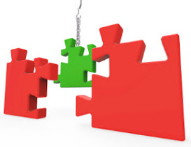
  - has less government rules that stops people from trying new ways of doing things

  - is a good way to support people.

Goals for government departments
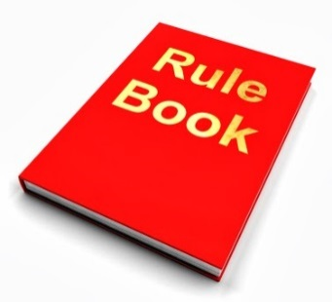
- All government departments to have the same rules and goals about disability support funding.
- To have just 1 way to check how things are going.

- To make sure that people’s money is always being spent in a way that fits with the values of Enabling Good Lives.

- For disabled people to be able to trust the government will do the right things.

What needs to happen for
Enabling Good Lives to work?
There are 5 things that need to happen for Enabling Good Lives to work:

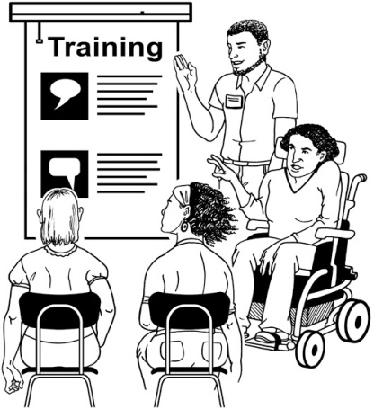
- There must be a chance for disabled people to learn:
  - about the new system
  - the skills they need to use the new system.

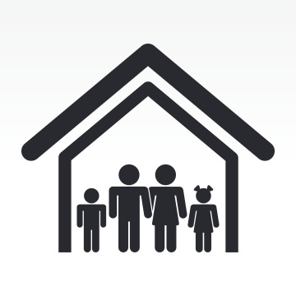
- Families/whānau need to be supported to help family members:
  - to have a good life
  - to have dreams and goals.

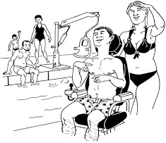
- Communities need to change how they see disabled people.

Communities must be accessible to disabled people.

This means disabled people are:
  - welcome in the community
  - treated well
  - seen as valued members of the community.

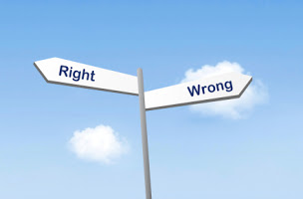
- Services need to change so that they follow the rules of Enabling Good Lives.

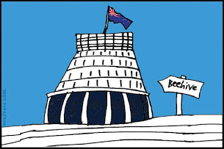
- There must be changes at a government level to the way that things are done.

This information has been translated into Easy Read
by People First New Zealand Inc.- Ngā Tāngata Tuatahi

